LAB221 Assignment | Type: | Short Assignment
 | Code: | J2.S.P0103
 | LOC: | 15
 | Slot(s): | 1

Title
Adjust scrollbar position to change font size
Background Context
NA

Program Specifications
Create a program to adjust scrollbar position to change font size, scrollbar move up then font size is decrease, scrollbar move down then font size is increase.

Function details:
NA

Expectation of User interface:
The screen when the program startup should be as:

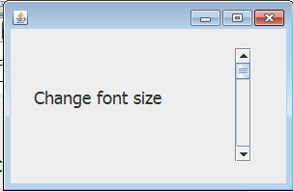

Font size is increase when move down scrollbar

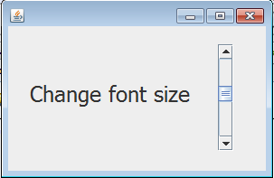

Guidelines

